Network Security Assessment Report
Task 1: Basic Network Scanning with Nmap
Date: June 18, 2026 | Tool: Nmap | Platform: Kali Linux

1. Executive Summary
This report documents the findings of a basic network reconnaissance scan performed on a local virtual machine using Nmap version 7.99. The objective was to identify open ports and running services as part of Task 1 of the network security assessment exercise. The scan was conducted on Kali Linux using both a default TCP scan and a service version detection scan.

2. Scan Environment
Parameter | Value
Analyst Machine | Kali Linux
Target IP Address | 192.168.1.122
Network Subnet | 192.168.1.0/24
Network Interface | eth0 (08:00:27:8a:35:d2)
Nmap Version | 7.99
Scan Date & Time | June 18, 2026 — 16:55 (UTC-4)
IP Assignment | Dynamic (DHCP)

3. Commands Executed
The following Nmap commands were run during the assessment:

Step 1 — Install Nmap:
sudo apt install nmap
Step 2 — Basic Port Scan:
nmap 192.168.1.122
Step 3 — Service Version Detection Scan:
nmap -sV 192.168.1.122

4. Scan Screenshot
The screenshot below captures the terminal output from all commands executed during the assessment, including the Nmap installation, IP address enumeration, and both scan results.

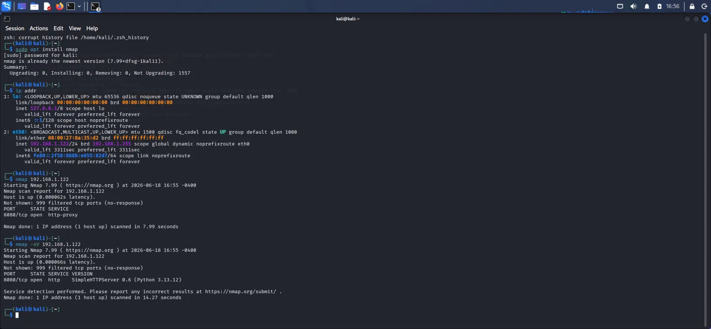
Figure 1: Nmap scan terminal output on Kali Linux (2026-06-18)

5. Scan Results & Open Port Findings

5.1 Scan 1 — Basic TCP Scan (nmap 192.168.1.122)
Port | State | Protocol | Service
8080/tcp | OPEN | TCP | http-proxy
999 others | FILTERED | TCP | (no response — firewall active)

5.2 Scan 2 — Service Version Detection (nmap -sV 192.168.1.122)
Port | State | Protocol | Service | Version
8080/tcp | OPEN | HTTP | SimpleHTTPServer | Python 3.13.12 v0.6

6. Significance of Open Port 8080
Only one open port was discovered on the target machine. Below is a detailed analysis of its significance from both a functional and security perspective.

6.1 What is Port 8080?
Port 8080 is an alternative to the standard HTTP port (80). It is commonly used for development web servers, proxy services, and testing environments. In this case, the service fingerprinting revealed it is running Python's built-in SimpleHTTPServer module, version 0.6 on Python 3.13.12.

6.2 Security Implications
Risk Factor | Risk Level | Details
No Authentication | HIGH | Python SimpleHTTPServer has zero authentication. Anyone on the network can access all served files without credentials.
No Encryption | HIGH | Plain HTTP traffic is transmitted in cleartext. Credentials, files, and data can be intercepted via packet sniffing (e.g., Wireshark).
Version Fingerprinting | MEDIUM | Service version Python 3.13.12 was identified. Attackers can look up known CVEs and vulnerabilities for this exact version.
Potential C2/Staging | MEDIUM | A running SimpleHTTPServer is often associated with attacker file staging (malware delivery) or exfiltration in real-world scenarios.
Directory Exposure | HIGH | If started from a sensitive directory, all files within (including configs, scripts, keys) are browsable by anyone on the network.

6.3 Significance of 999 Filtered Ports
The remaining 999 TCP ports were all in a FILTERED state, meaning a firewall is silently dropping connection attempts. This is a good security posture, as it minimises the attack surface and makes reconnaissance harder. Only port 8080 was intentionally left open.

7. Recommendations
Based on the scan findings, the following actions are recommended:

- Disable SimpleHTTPServer when not in active use — it is a temporary development tool and should never run unattended.
- Never expose SimpleHTTPServer to a production or internet-facing environment.
- If a web server is required, use a hardened alternative (e.g., Apache or Nginx) with authentication and TLS/HTTPS enabled.
- Restrict access to port 8080 using firewall rules (e.g., iptables or ufw) to only trusted IP addresses.
- If file serving is needed locally, bind the server to localhost only: python3 -m http.server --bind 127.0.0.1 8080
- Assign a static IP address to the target machine to ensure consistent monitoring and access control.

8. Summary
Finding | Assessment
Open Ports Found | 1 (Port 8080/tcp)
Service Identified | Python SimpleHTTPServer 0.6 (HTTP)
Filtered Ports | 999 (Firewall active — good posture)
Encryption | None (plain HTTP)
Authentication | None
Overall Risk | LOW in lab/test environment; HIGH if exposed in production
Scan Scope | Controlled lab environment — ethical, authorized testing only

Note: This assessment was conducted in a controlled Kali Linux lab environment for educational purposes only. All scanning activity was performed on a local virtual machine with full authorization. No unauthorized systems were accessed.

